Dynamic Workflow Configuration in APS Activiti

# User Manual

Version 0.1

# Table of Contents

User Manual 1

Table of Contents 2

1. Configuring Repositories and Endpoints in APS 3

1.1 Configuring Alfresco Repository 3

1.2 Configuring Endpoints for ACS and APS 5

2. Configure APS User Accounts to ACS 11

3. APS user configurations for Workflows 14

4. Create Prerequisite Group for Dynamic Collaboration Workflow 17

5. Dynamic Collaboration Workflow App Configuration 24

5.1 Dynamic Collaboration Workflow App Configuration 24

# 1. Configuring Repositories and Endpoints in APS

Navigate to <http://localhost:8080/activiti-app/> and login using admin credentials (admin@app.activiti.com/admin)

## Configuring Alfresco Repository

**Configure Alfresco ACS Repository in ACS**

1. Add repository configurations, APS and ACS. Click ‘Identity Management’ from main page.

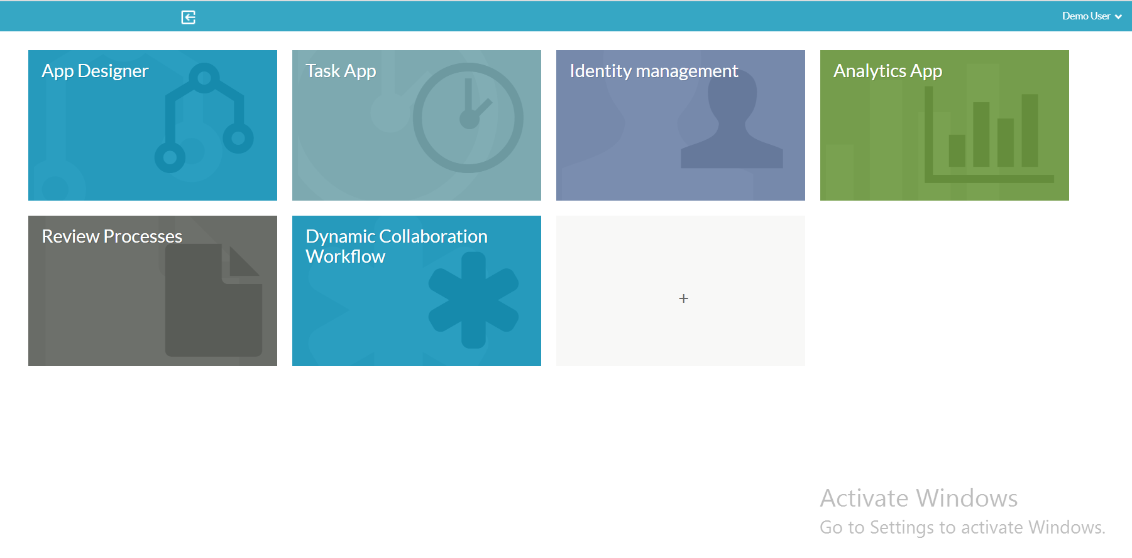

1. Click Tenants menu and click Alfresco Repositories.

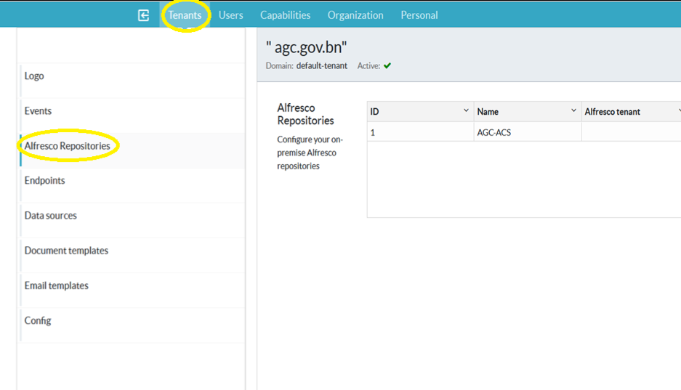

Add configurations as below

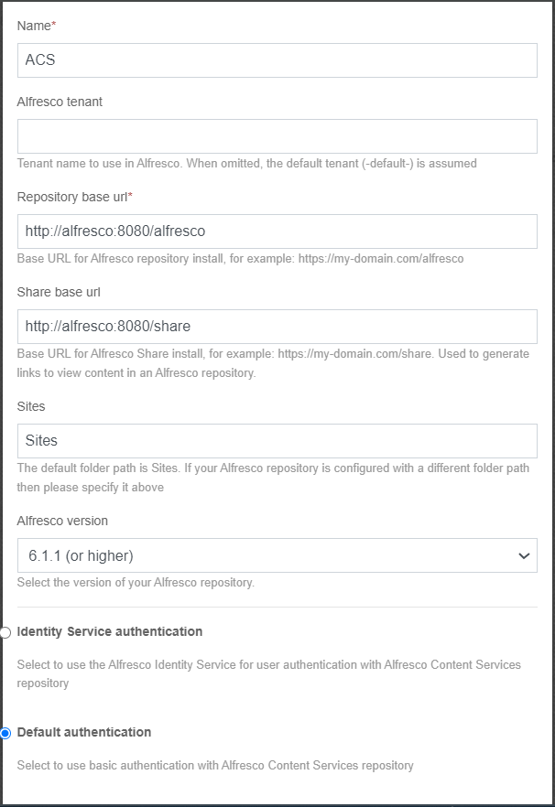

## Configuring Endpoints for ACS and APS

* + 1. **Basic Auth Configuration:**

1. Click endpoints and add the following **Basic Auth**.

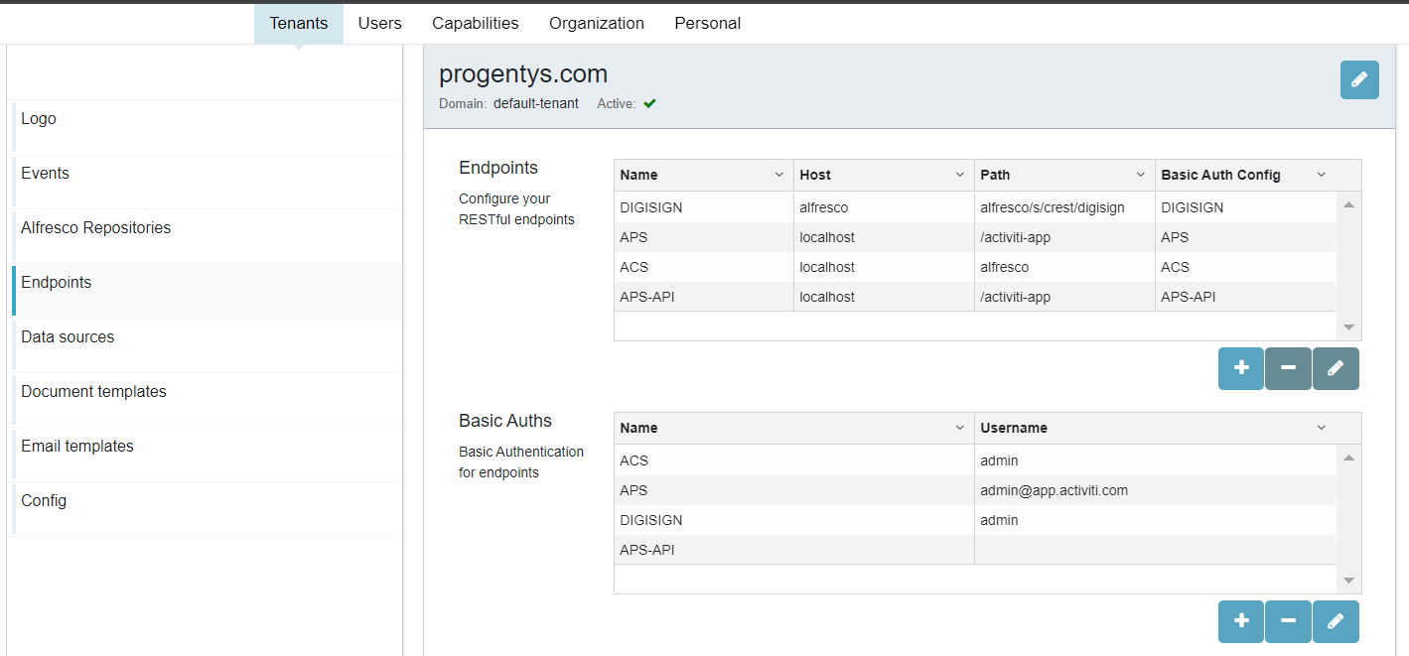

* 1. ACS Auth

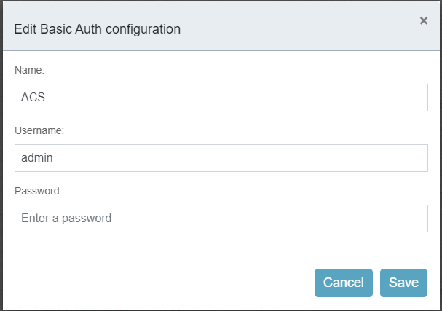

* 1. APS Auth

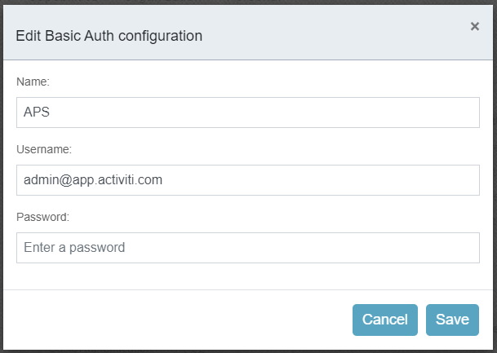

* 1. APS-API Auth, username and password are empty.

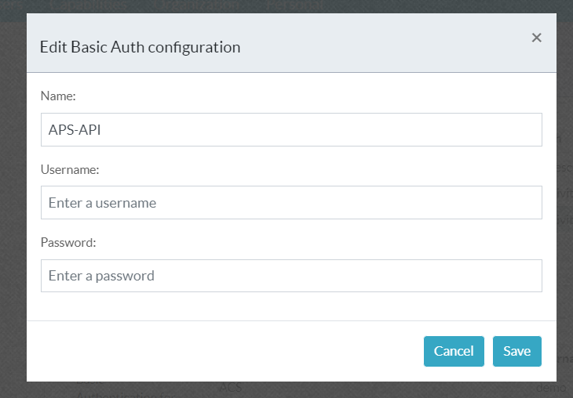

* + 1. **Endpoints Configuration:**

Add the endpoint configurations as below

1. ACS

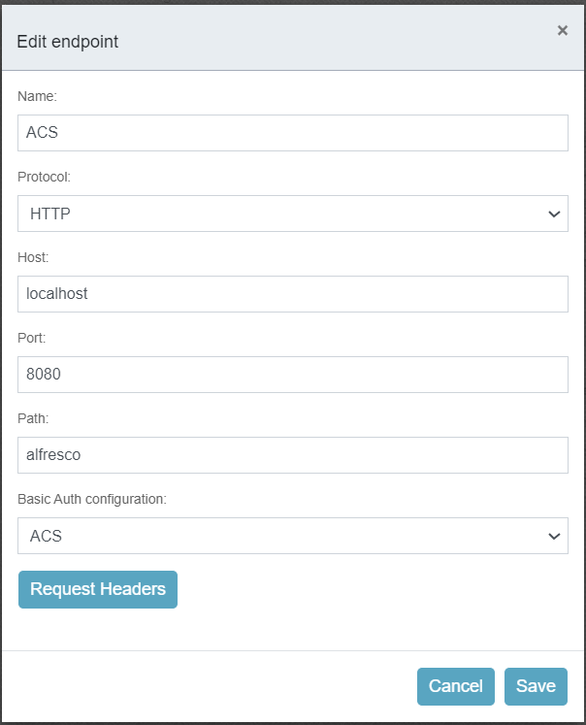

1. APS

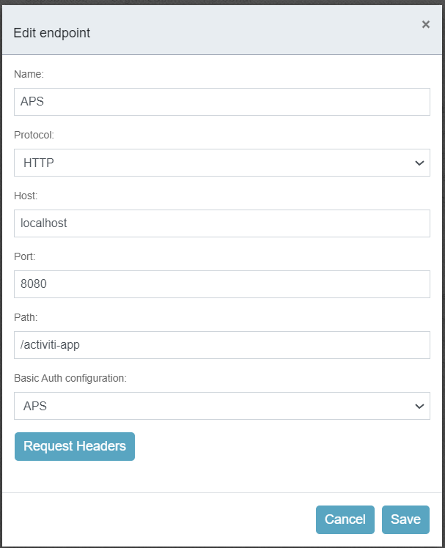

1. APS-API

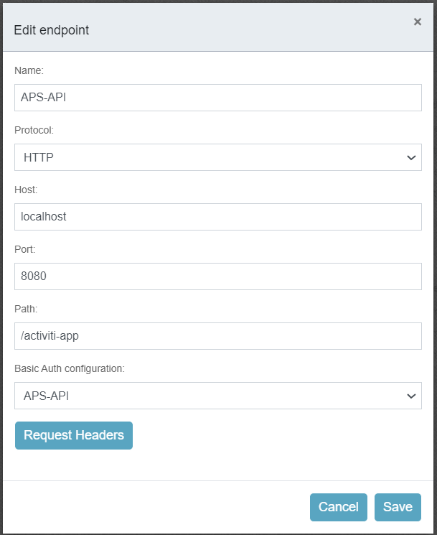

# 2. Configure APS User Accounts to ACS

1. Login to APS activiti with a user account that has to be part of any workflow.

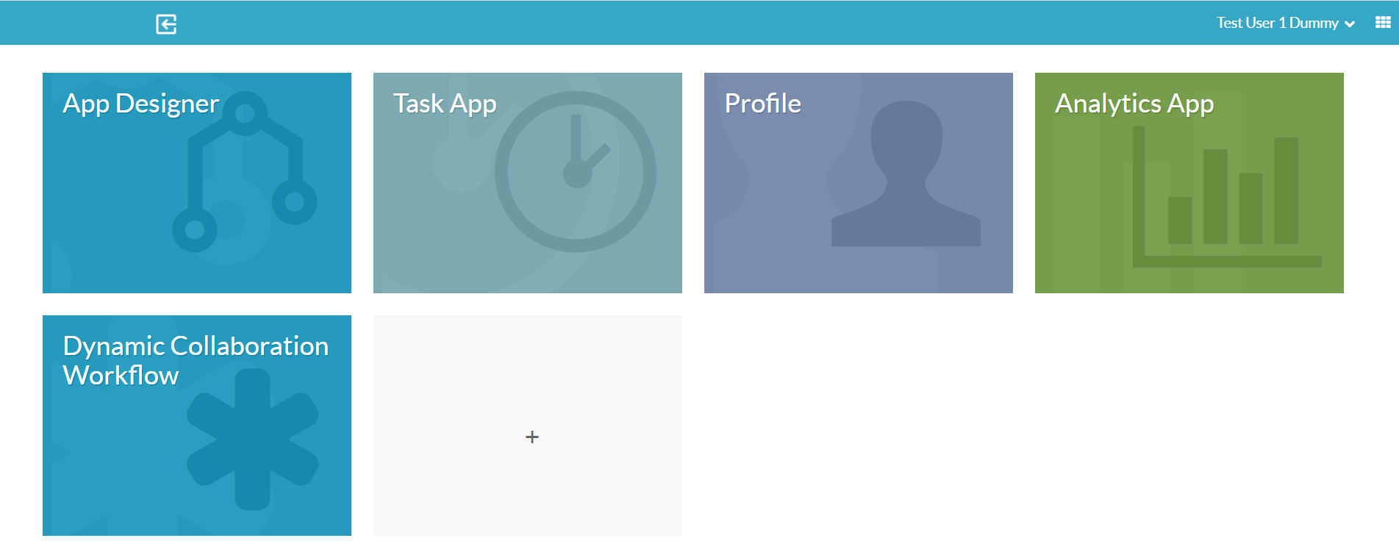

1. Click on user account and click Profile.

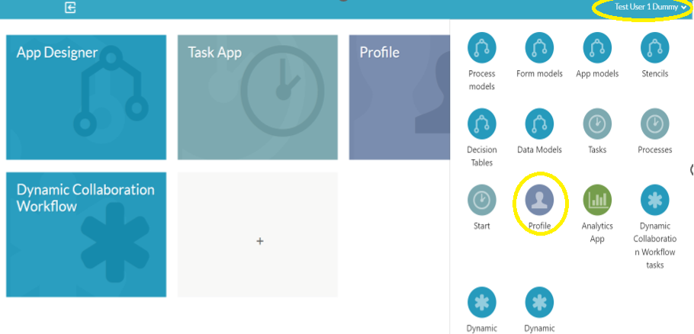

1. Go to the end of the page and click on Alfresco Repositories.

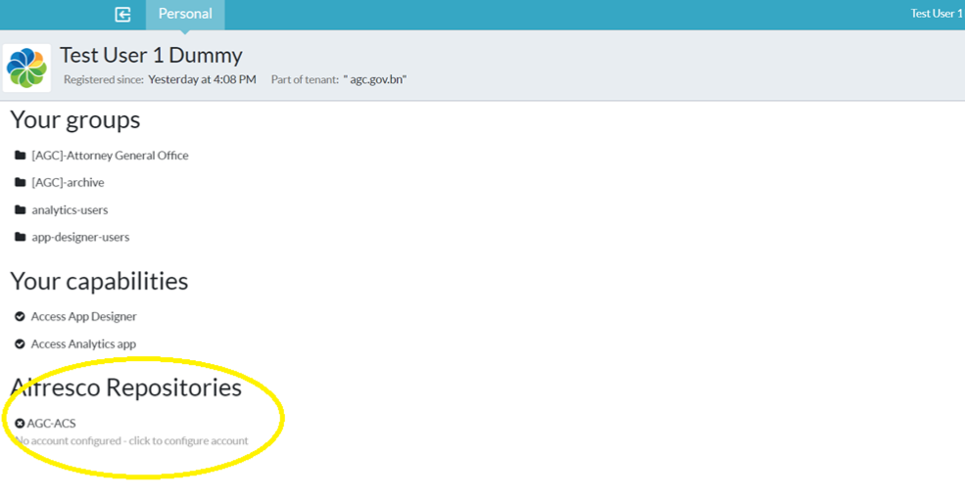

1. Enter user account credentials to **ACS** repository (not APS).

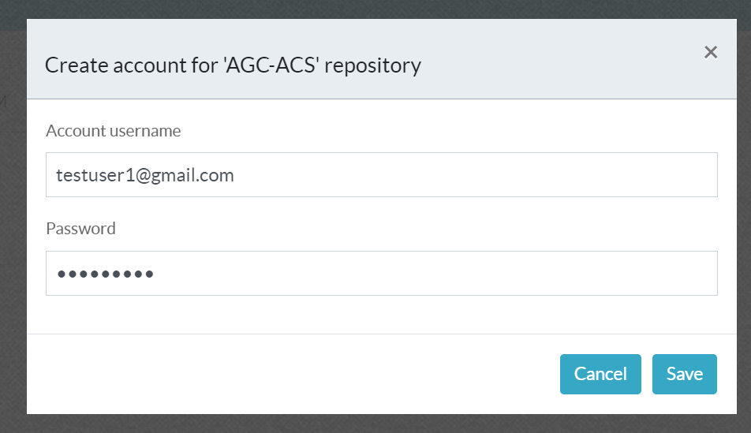

1. User if authenticated to ACS repository.

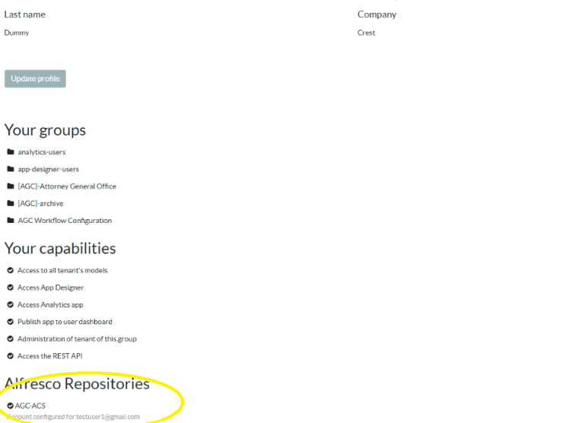

1. Do this for all user accounts involved with workflows.

# 3. APS user configurations for Workflows

1. Go back to the home page and click

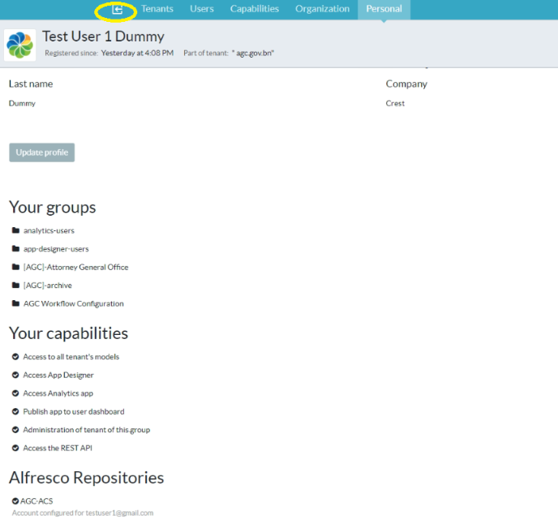

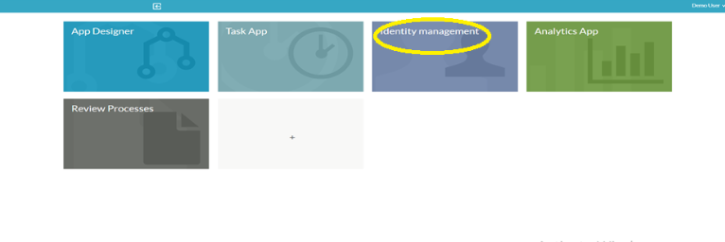

1. Click on Capabilities Menu item and click Create Group option. Workflow Management.

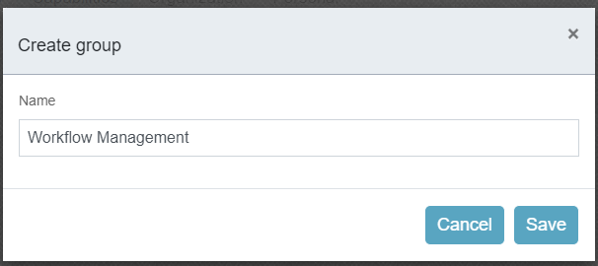

1. Click on Add Capabilities and add the following capabilities.

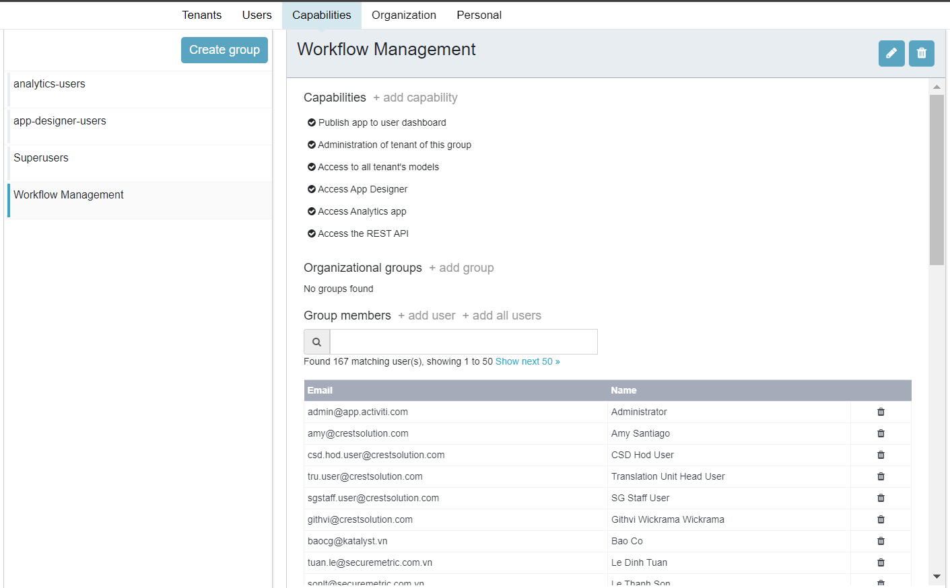

1. Add all capabilities except ‘Upload License’.

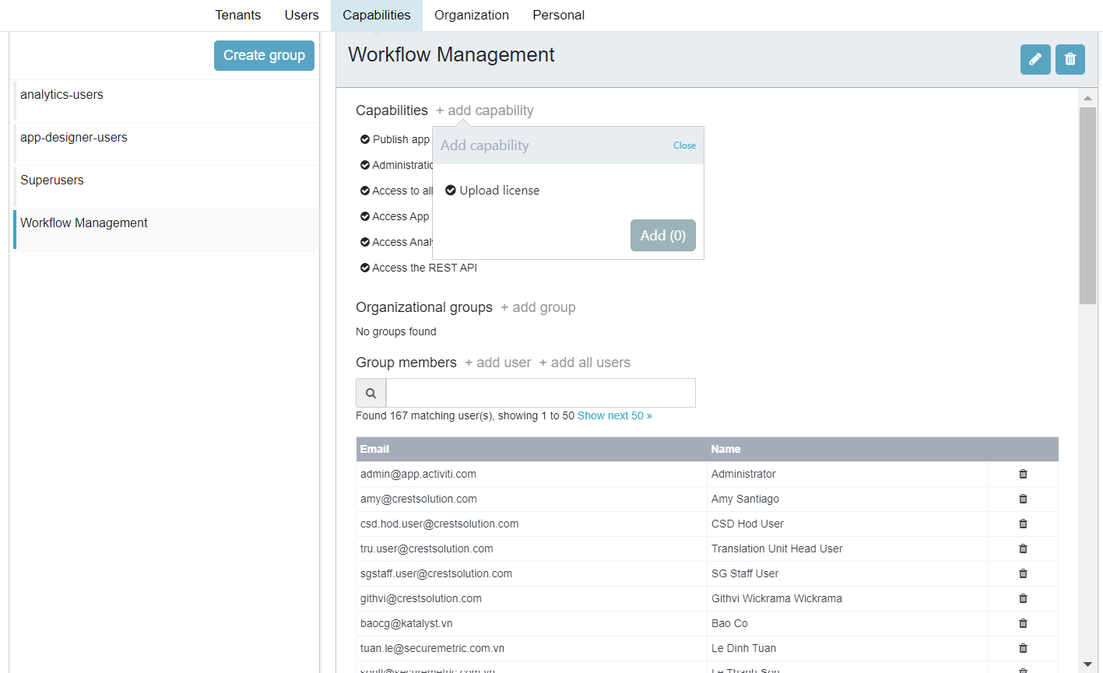

# 4.Create Prerequisite Group for Dynamic Collaboration Workflow

* 1. **Archive Group Configuration:**

1. Click ‘Organization’ menu item next and click ‘Create Group’ and name it as ‘Archive’ save.

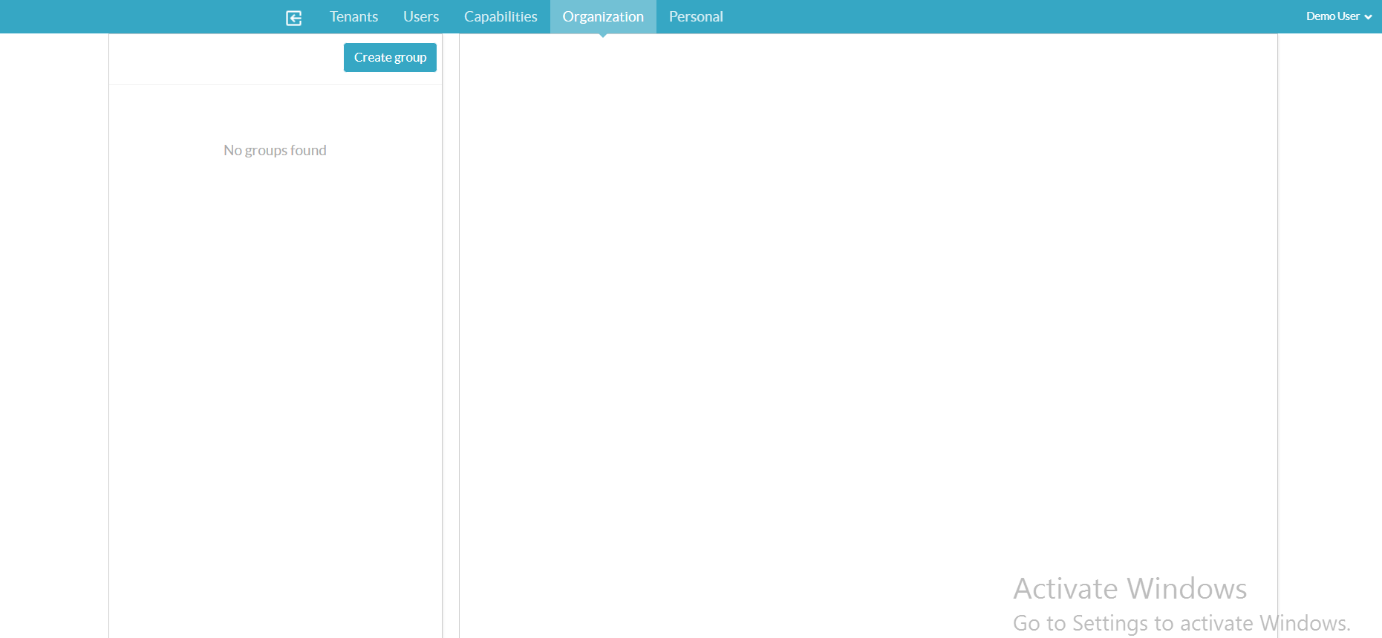

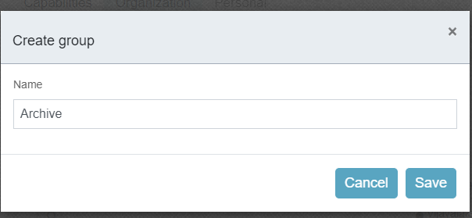

1. Select the user and user will be added to the group.

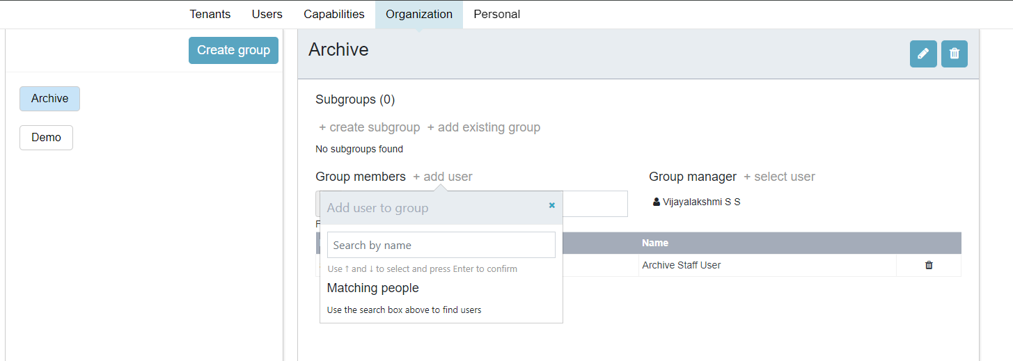

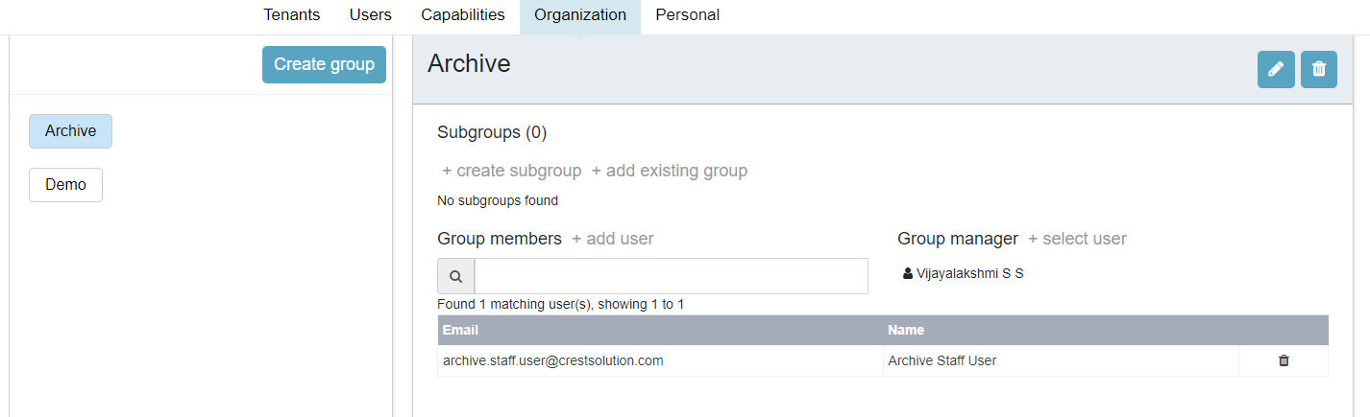

* 1. **Custom Email Templates Configuration:**

1. Go back to Tenants Menu item and click Email Templates from left menu and select email templates and then Create new email templates.

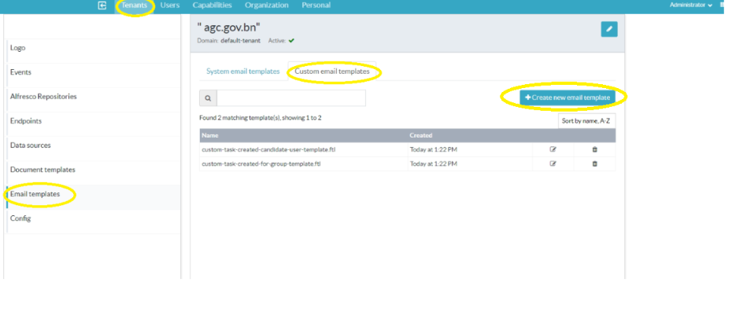

1. In the name add ‘custom-task-created-candidate-user-template.ftl’ and in subject add ‘EDMS-Task Reminder from ${taskCreator}!’. In the Email Content add the following and save it.

<html>

<body style="background-color: #e8edf1; padding: 0; margin: 0;">

<table width="100%" height="400" cellpadding="0" cellspacing="0" style="margin:0; padding:0">

<tr height="50"><td colspan="3"></td></tr>

<tr>

<td width="10%"></td>

<td width="80%" valign="top" >

<table style="background-color: #fff;padding: 0px;" width="100%" cellpadding="0" cellspacing="0">

<tr height="30"><td colspan="3"></td></tr>

<tr>

<td width="15"></td>

<td valign="center"style="font-size: 16px;font-family: 'Open Sans', Helvetica, sans-serif; font-weight: bold; "> EDMS-Task Reminder</td>

<td width="15"></td>

</tr>

<tr height="30"><td colspan="3"></td></tr>

<tr height="1" style="background-color: #e8edf1;"><td colspan="3"></td></tr>

<tr>

<td width="15"></td>

<td width="30">

<pre style="font-size: 14px;font-family: 'Open Sans', Helvetica, sans-serif;padding-top: 50px;">Dear ${userName}, </pre> <br>

<pre style="font-size: 14px;font-family: 'Open Sans', Helvetica, sans-serif;">Please find below the reminder of the pending <strong><#if userOrGroup=='task'>Task<#else>Group Task</#if></strong> assigned to you.</pre>

<pre style="font-size: 14px;font-family: 'Open Sans', Helvetica, sans-serif;">Workflow Name: <strong>${processName}</strong></pre>

<pre style="font-size: 14px;font-family: 'Open Sans', Helvetica, sans-serif;">Task Status: <strong>${taskStatus}</strong></pre>

<center><pre style="font-size: 14px;font-family: 'Open Sans', Helvetica, sans-serif;"><strong><a href="${taskUrl}" title="Open the task" style="text-decoration: none; text-align: center;color: #ffffff; display: inline-block; width: 300px; padding: 10px 0px;background-color: #36a7c4; border-radius: 3px; -moz-border-radius: 3px; -webkit-border-radius: 3px;">Open the task</a></strong></pre></center>

<pre style="font-size: 14px;font-family: 'Open Sans', Helvetica, sans-serif;">For any enquiries or assistance, please contact EDMS helpdesk at xxxxx or email@edms.gov.bn</strong></pre>

<pre style="font-size: 14px;font-family: 'Open Sans', Helvetica, sans-serif;"><strong>* This is a computer generated email, please do not reply. *</strong></pre>

<br/><br><pre style="font-size: 14px;font-family: 'Open Sans', Helvetica, sans-serif;">Thanks for reading.</pre>

</td>

<td width="15"></td>

</tr>

<tr height="30"><td colspan="3"></td></tr>

<tr height="25"><td colspan="3"></td></tr>

</table>

</td>

<td width="10%"></td>

</tr>

<tr height="50"><td colspan="3"></td></tr>

</table>

</body>

</html>

1. A new template is added.

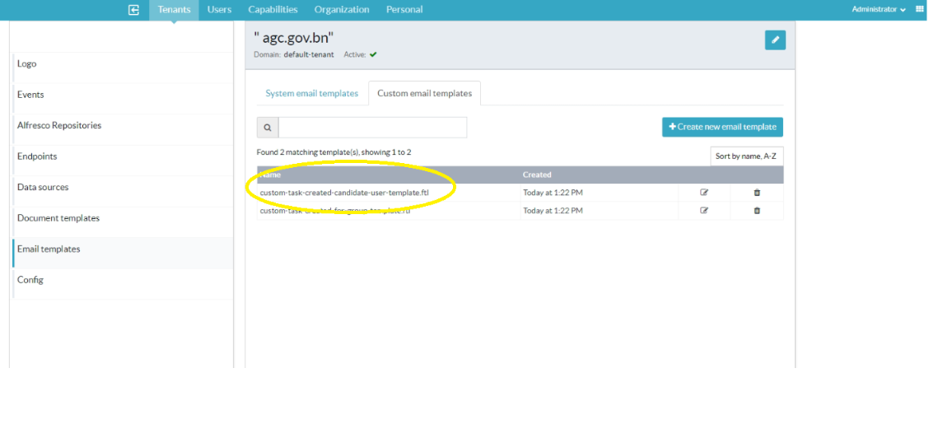

1. Add another template for groups.

Name: custom-task-created-for-group-template.ftl

Subject: EDMS-Task Reminder from ${taskCreator}!

Email Content:

<html>

<body style="background-color: #e8edf1; padding: 0; margin: 0;">

<table width="100%" height="400" cellpadding="0" cellspacing="0" style="margin:0; padding:0">

<tr height="50"><td colspan="3"></td></tr>

<tr>

<td width="10%"></td>

<td width="80%" valign="top" >

<table style="background-color: #fff;padding: 0px;" width="100%" cellpadding="0" cellspacing="0">

<tr height="30"><td colspan="3"></td></tr>

<tr>

<td width="15"></td>

<td valign="center"style="font-size: 16px;font-family: 'Open Sans', Helvetica, sans-serif; font-weight: bold; ">EDMS-Task Reminder</td>

<td width="15"></td>

</tr>

<tr height="30"><td colspan="3"></td></tr>

<tr height="1" style="background-color: #e8edf1;"><td colspan="3"></td></tr>

<tr>

<td width="30"></td>

<pre style="font-size: 14px;font-family: 'Open Sans', Helvetica, sans-serif;padding-top: 50px;">Dear ${taskCreator}, </pre> <br>

<pre style="font-size: 14px;font-family: 'Open Sans', Helvetica, sans-serif;">Please find below the reminder of the pending task assigned to you.</pre>

<pre style="font-size: 14px;font-family: 'Open Sans', Helvetica, sans-serif;">Workflow Name: <strong>${processName}</strong></pre>

<pre style="font-size: 14px;font-family: 'Open Sans', Helvetica, sans-serif;">Task Status: <strong>${taskStatus}</strong></pre>

<pre style="font-size: 14px;font-family: 'Open Sans', Helvetica, sans-serif;"><strong><a href="${taskUrl}" title="Open the task" style="text-decoration: none; text-align: center;color: #ffffff; display: inline-block; width: 300px; padding: 10px 0px;background-color: #36a7c4; border-radius: 3px; -moz-border-radius: 3px; -webkit-border-radius: 3px;">Open the task</a></strong></pre>

<pre style="font-size: 14px;font-family: 'Open Sans', Helvetica, sans-serif;">For any enquiries or assistance, please contact EDMS helpdesk at xxxxx or email@edms.gov.bn</strong></pre>

<pre style="font-size: 14px;font-family: 'Open Sans', Helvetica, sans-serif;"><strong>* This is a computer generated email, please do not reply. *</strong></pre>

<br/><br><pre style="font-size: 14px;font-family: 'Open Sans', Helvetica, sans-serif;">Thanks for reading.</pre>

</td>

<td width="15"></td>

</tr>

<tr height="30"><td colspan="3"></td></tr>

<tr height="25"><td colspan="3"></td></tr>

</table>

</td>

<td width="10%"></td>

</tr>

</table>

</body>

</html>

# 5. Dynamic Collaboration Workflow App Configuration

## Dynamic Collaboration Workflow App Configuration

1. Click App Designer from Main page.

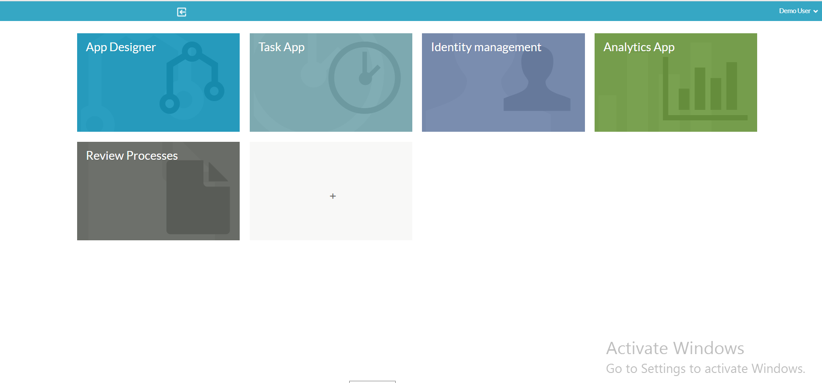

1. Click App Menu.

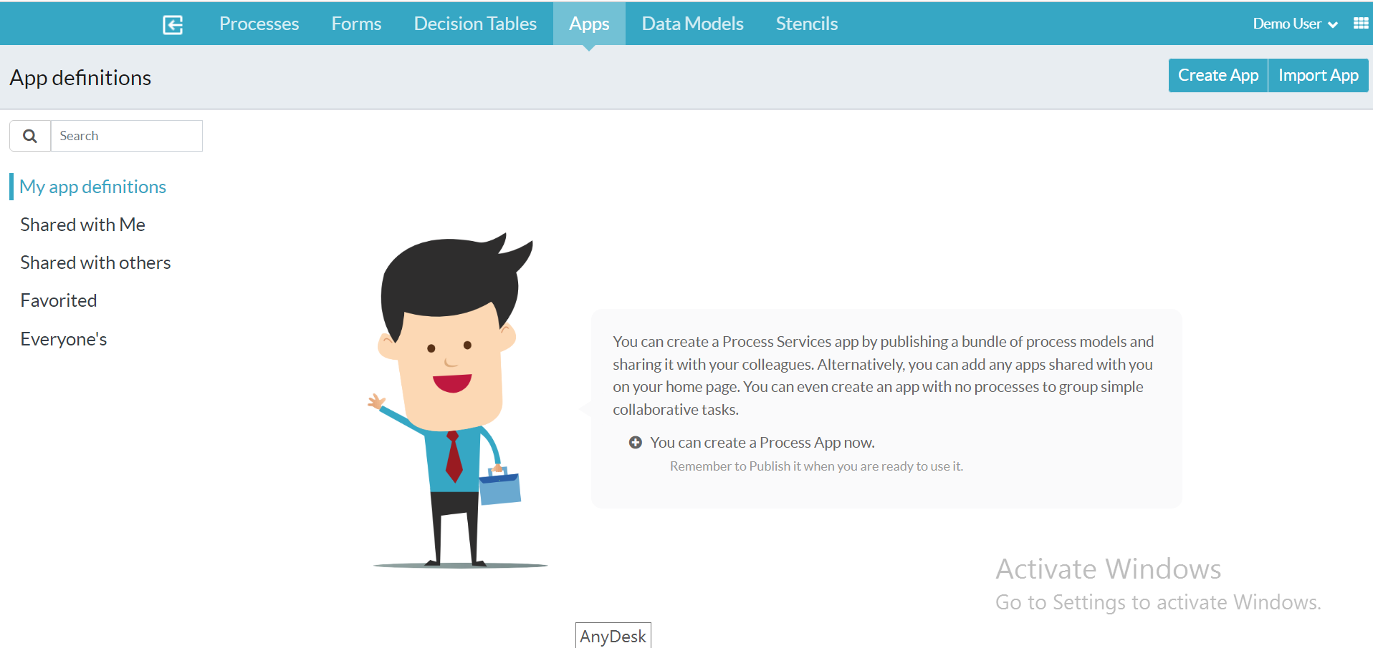

1. Click Import App button and check the Renew button as shown below.

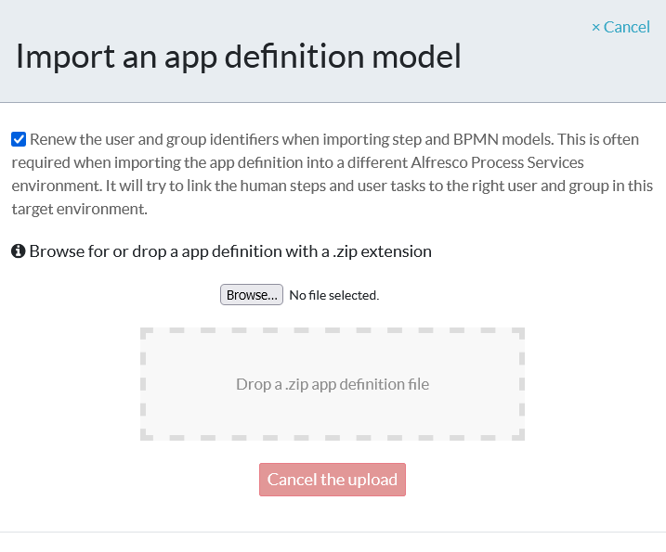

1. Select the Dynamic Collaboration Workflow App from the documentation folder.

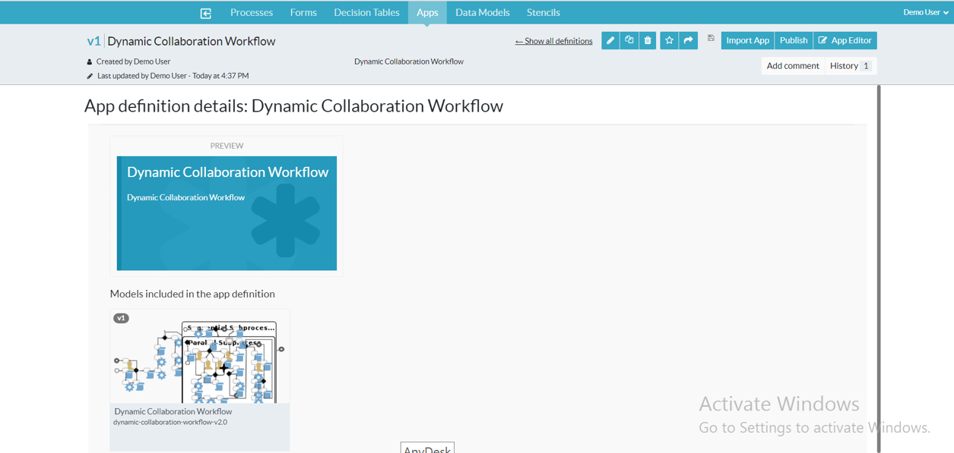

1. Remove user and group accounts that are configured in the app as they do not exist in this new environment. Click the cross beside each user/group.

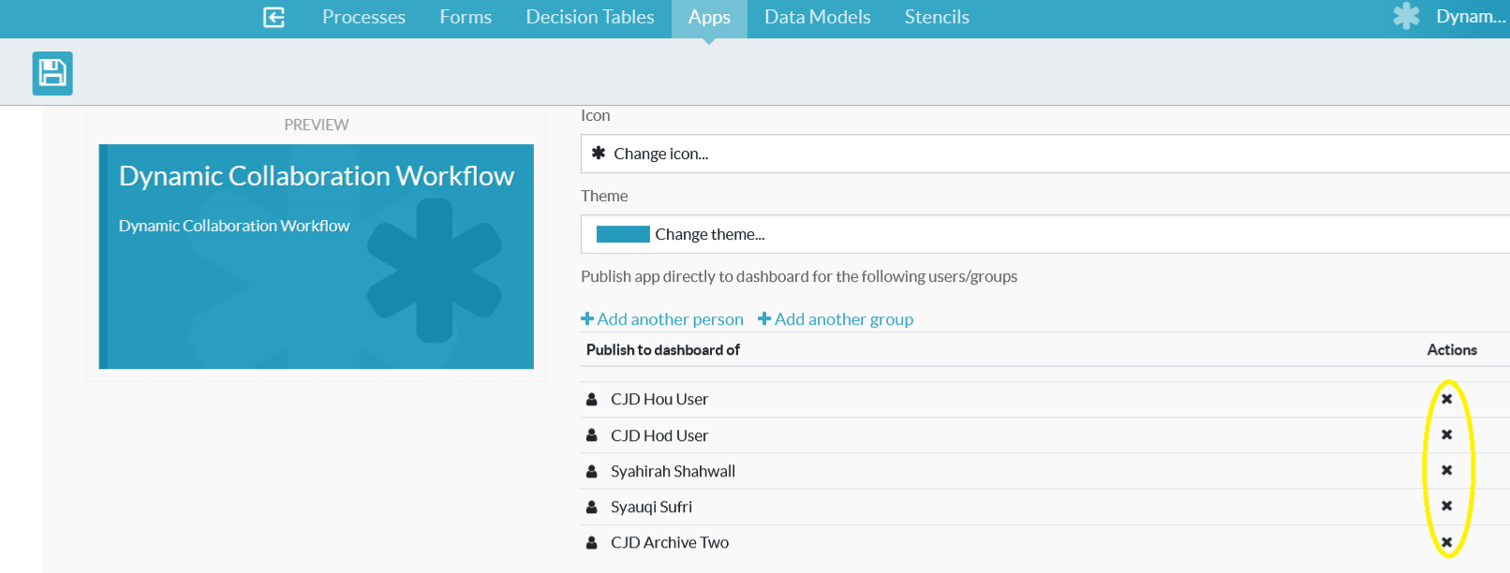

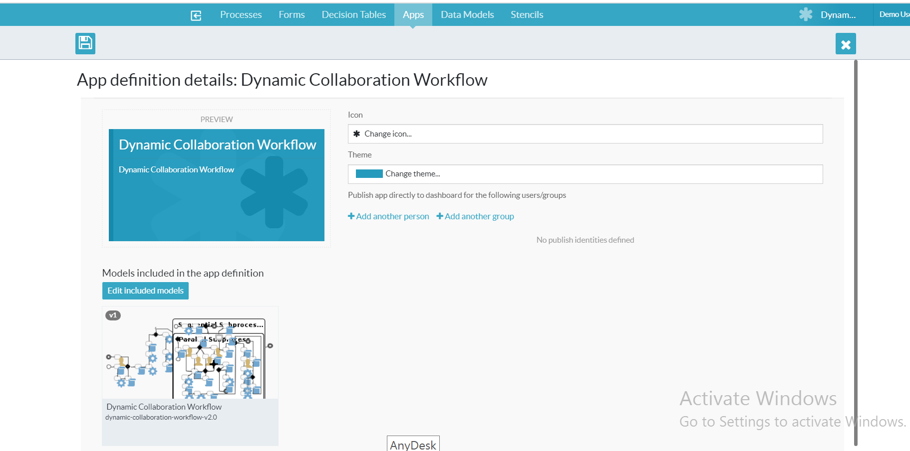

1. Add users and groups that are in this new environment by clicking the ‘Add Another User’ link and selecting users.

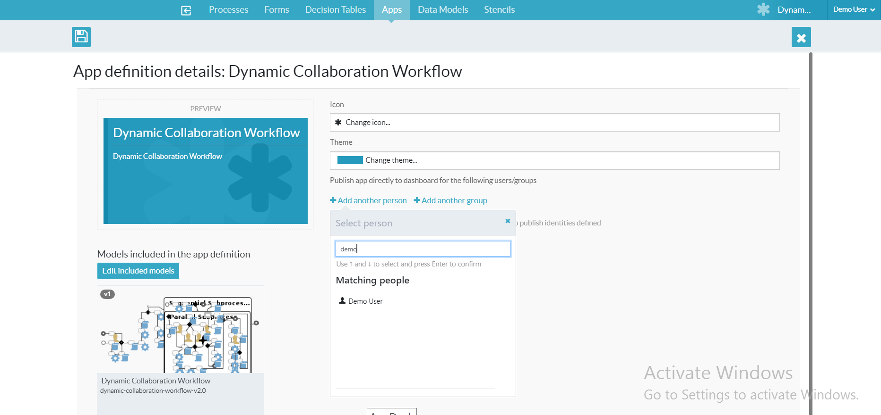

1. Select the user and the user gets added to the app.



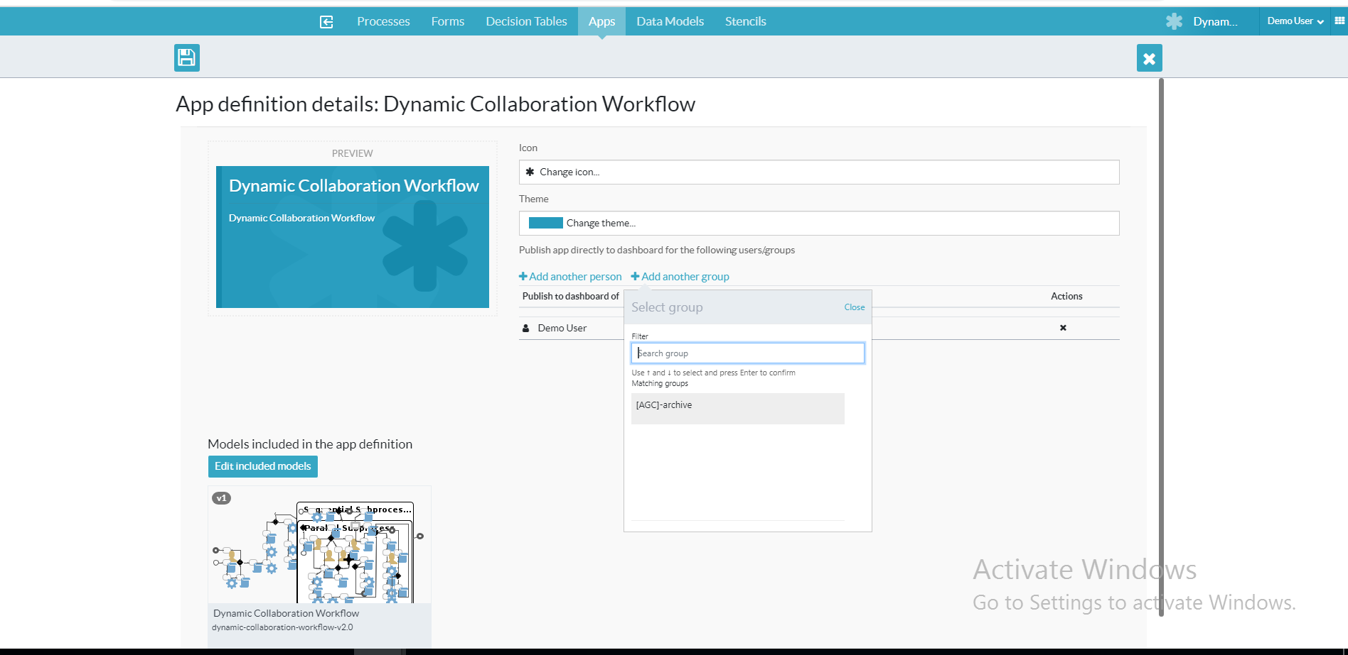

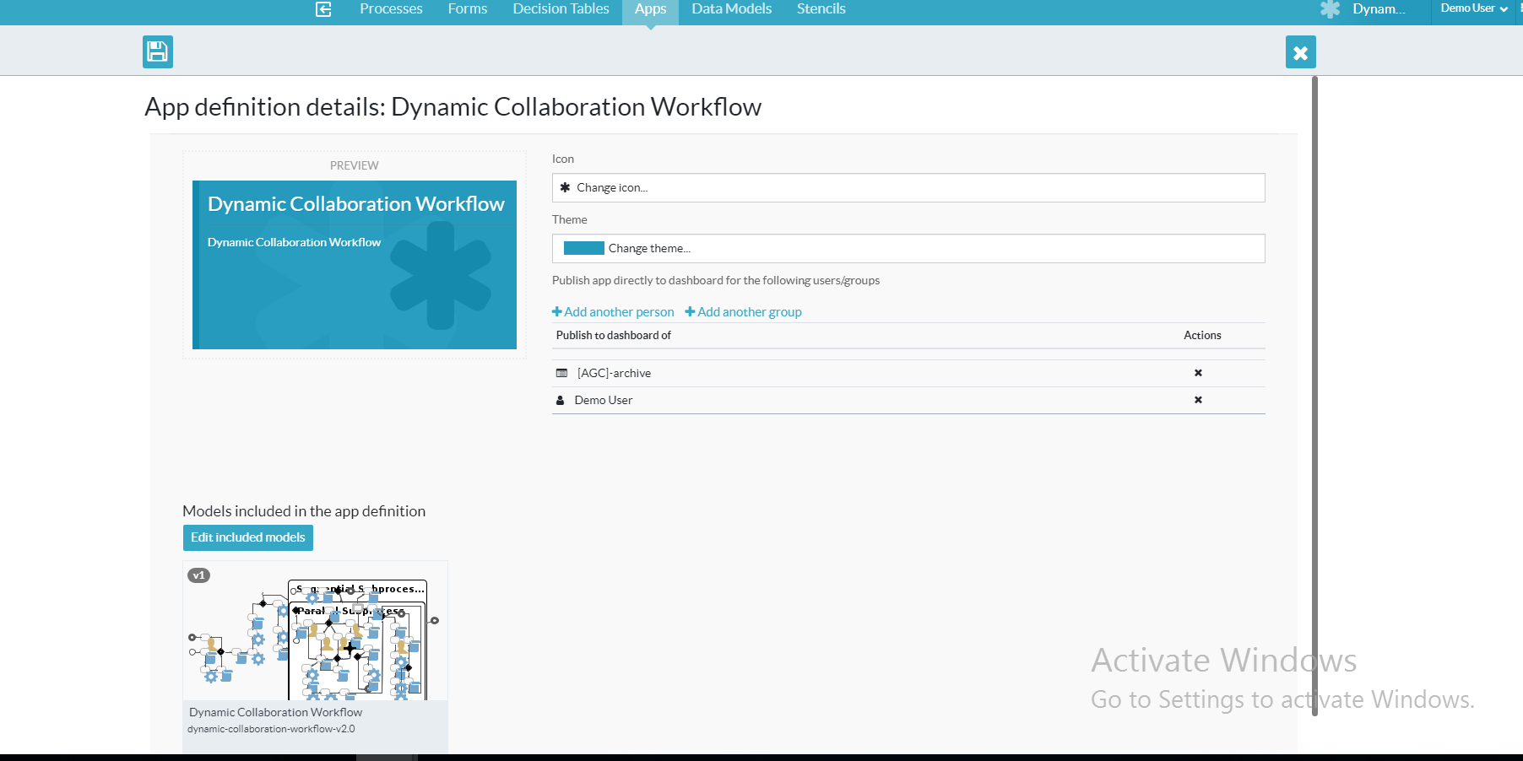

1. Save the app.

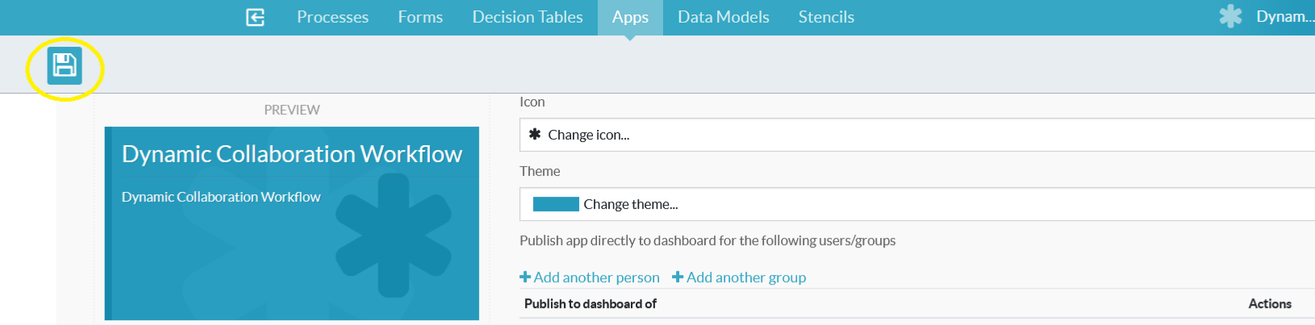

1. Tick the publish checkbox and ‘Save and close editor’.

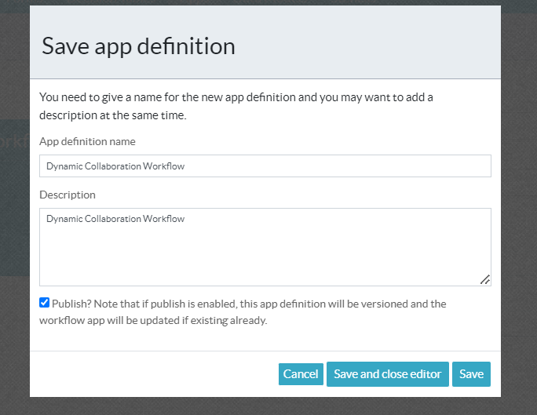

1. The app is published, go to the main page by clicking the menu item like screenshot.

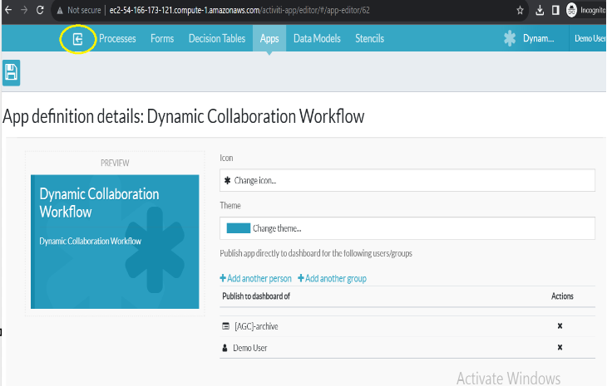

1. The app appears in the main page.

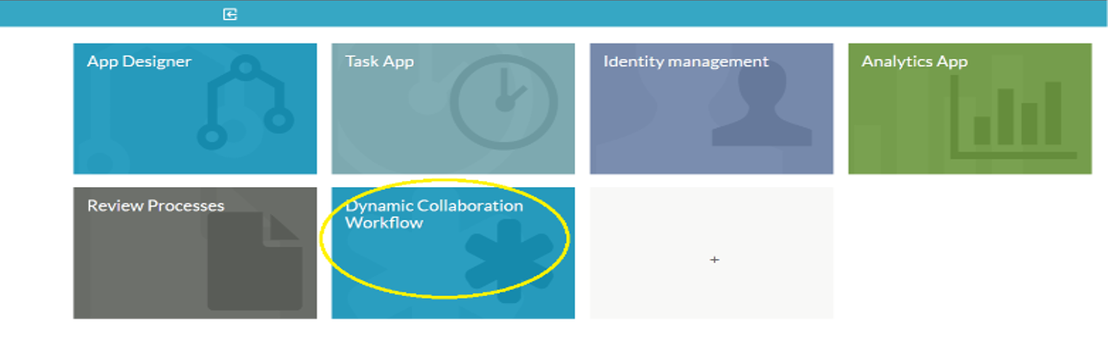

1. Click the app to initiate a new Dynamic Collaboration Workflow from activiti.

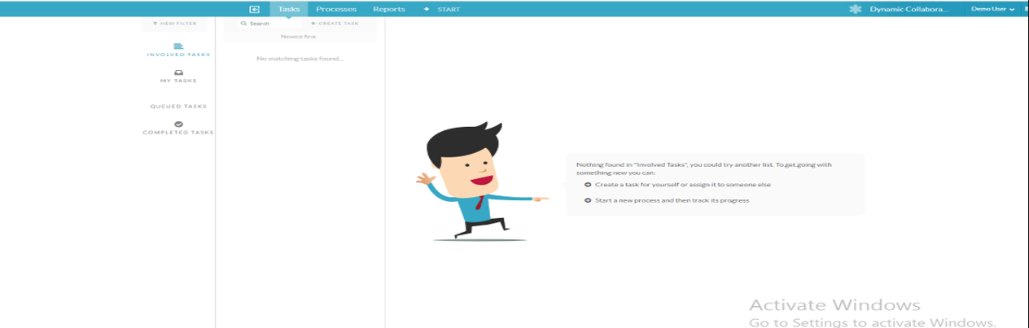

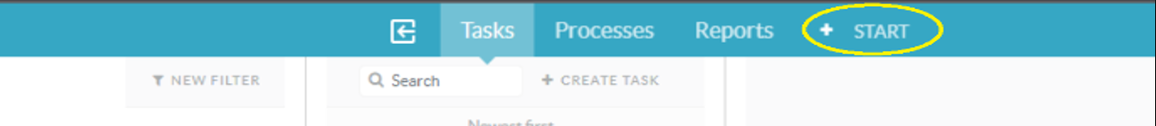

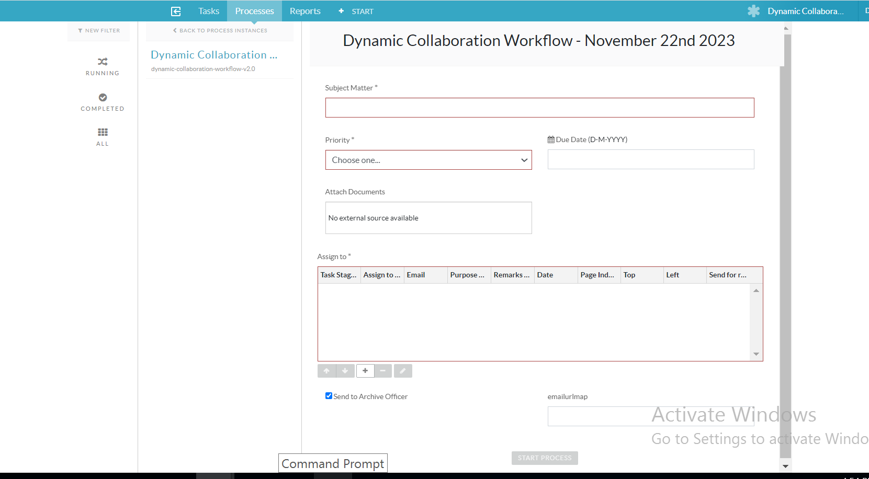

1. Login to digiworks to start new Dynamic Collaboration Workflow too.

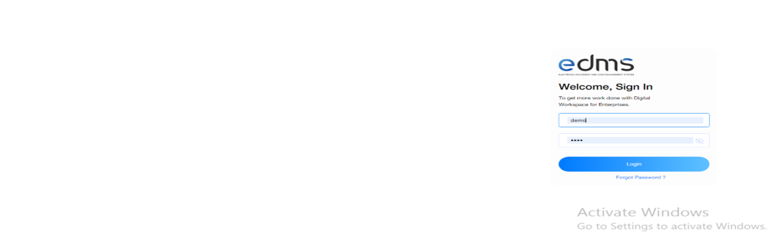

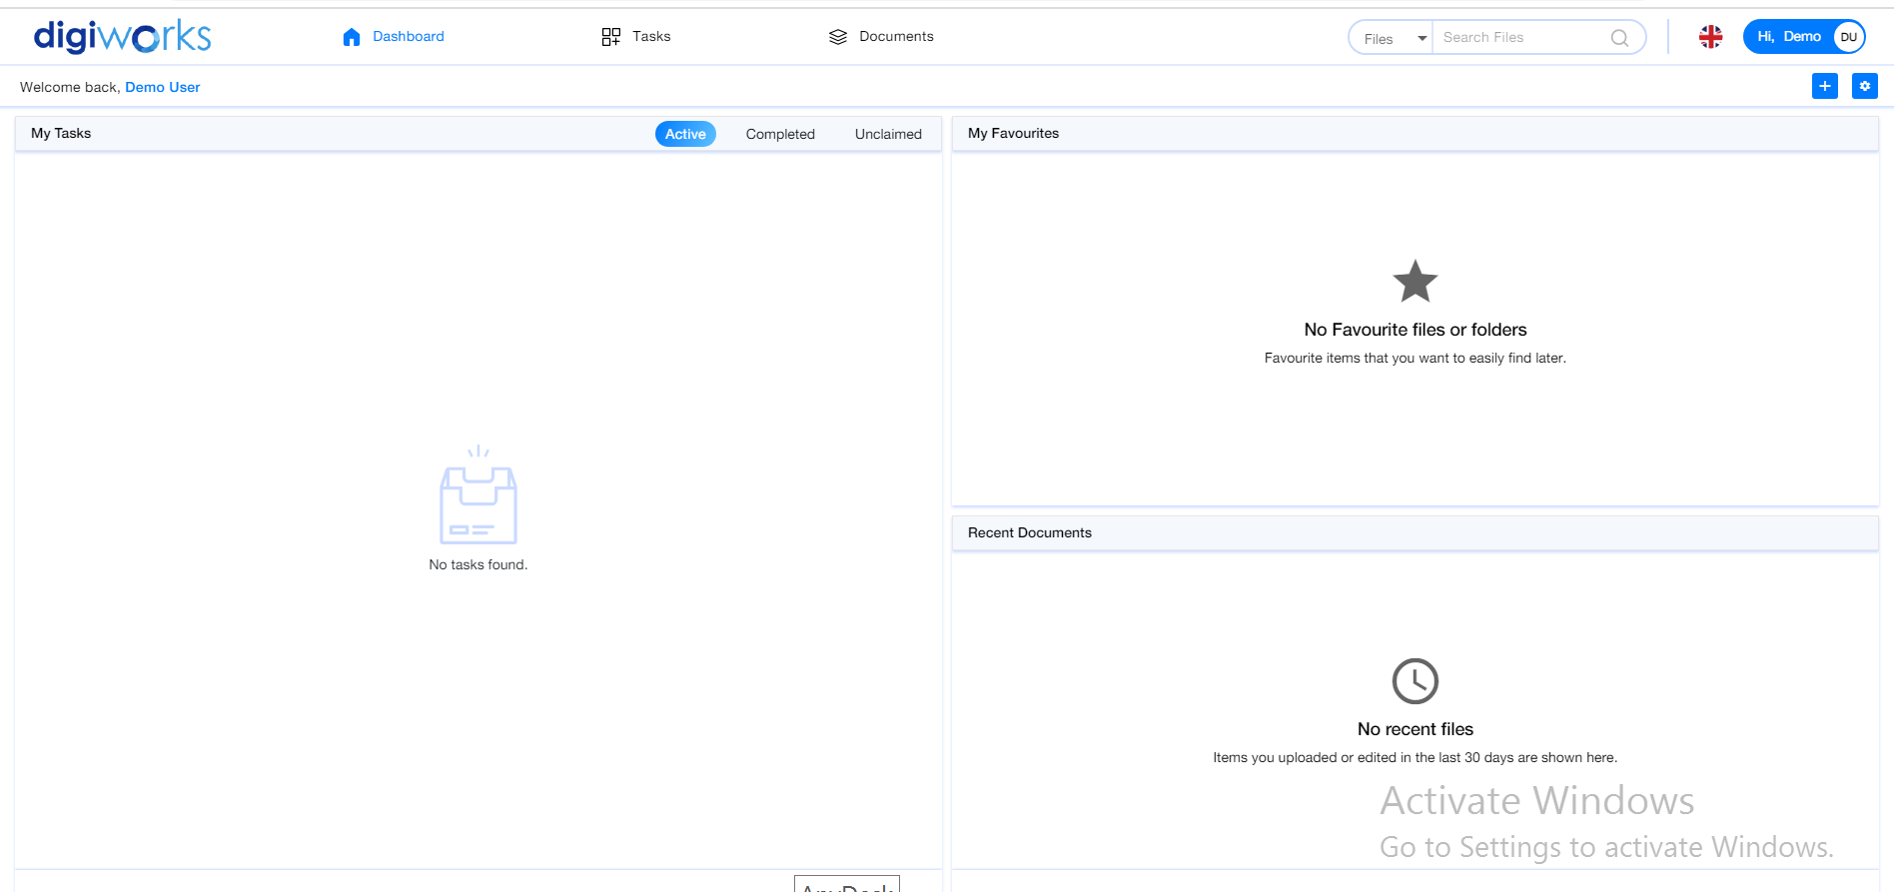

1. Click Tasks menu item and click Dynamic Collaboration Workflow.

